|  |
| --- |
| **Machine NAS v1.1** |

1 Configuration 2

1.1 Switch Config 2

1.2 Synology network 3

1.3 Create a new Volume 3

1.4 Users and Shares 4

1.5 Setup snapshots 5

# Configuration

Compare this manual with the manual *“JDN Standards – synology SHA”.*

## Switch Config

First reconfigure the following ports on the XX-SW01 and increase Aggregated-devices count.

set chassis aggregated-devices ethernet device-count 4

delete vlans crew-dia interface ge-0/0/34.0

delete vlans crew-dia interface ge-1/0/34.0

delete vlans crew-dia interface ge-0/0/35.0

delete vlans crew-dia interface ge-1/0/35.0

delete vlans crew-dia interface ge-0/0/36.0

delete vlans crew-dia interface ge-1/0/36.0

delete interfaces ge-0/0/34

delete interfaces ge-1/0/34

delete interfaces ge-0/0/35

delete interfaces ge-1/0/35

delete interfaces ge-0/0/36

delete interfaces ge-1/0/36

set interfaces ge-0/0/34 description "SYNOLOGY01 MACHINE"

set interfaces ge-0/0/34 ether-options 802.3ad ae2

set interfaces ge-0/0/35 description "SYNOLOGY02 MACHINE"

set interfaces ge-0/0/35 ether-options 802.3ad ae3

set interfaces ge-0/0/36 description "SYNOLOGY01 MACHINE MGMT"

set interfaces ge-0/0/36 unit 0 family ethernet-switching

set interfaces ge-1/0/34 description "SYNOLOGY01 MACHINE"

set interfaces ge-1/0/34 ether-options 802.3ad ae2

set interfaces ge-1/0/35 description "SYNOLOGY02 MACHINE"

set interfaces ge-1/0/35 ether-options 802.3ad ae3

set interfaces ge-1/0/36 description "SYNOLOGY02 MACHINE MGMT"

set interfaces ge-1/0/36 unit 0 family ethernet-switching

set interfaces ae2 description "SYNOLOGY01 MACHINE LACP"

set interfaces ae2 aggregated-ether-options lacp active

set interfaces ae2 unit 0 family ethernet-switching

set interfaces ae3 description "SYNOLOGY02 MACHINE LACP"

set interfaces ae3 aggregated-ether-options lacp active

set interfaces ae3 unit 0 family ethernet-switching

set vlans admin-trust interface ge-0/0/36.0

set vlans admin-trust interface ge-1/0/36.0

set vlans machine interface ae2.0

set vlans machine interface ae3.0

## Synology network

Use the following network settings on the Synology.

Change the XX with the Admin-Trust range of the vessel/office.

Change the YY with the Machine range of the vessel/office.

|  |  |  |  |
| --- | --- | --- | --- |
|  | XX-MACHSYN01 | XX-MACHSYN02 | XX-MACHSYNCL01 |
| Admin-Trust (Lan 4) | 10.x.x.44 /24 | 10.x.x.45 /24 | 10.x.x.43 /24 |
| Machine (Bond 1) | 10.y.y.211 /24 | 10.y.y.212 /24 | 10.y.y.210 /24 |

## Create a new Volume

Select Btrfs instead of EXT4 when creating the new volume

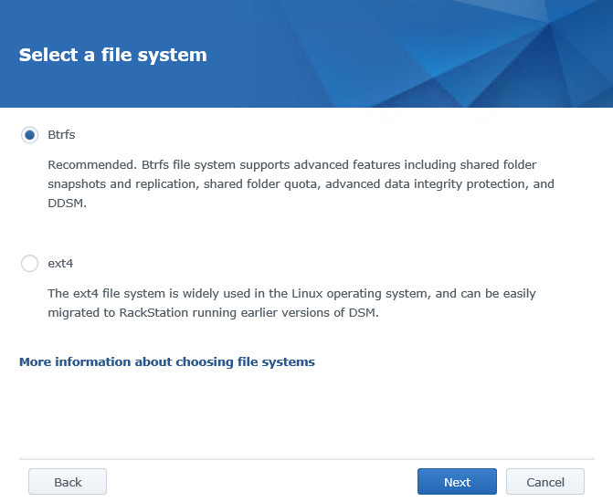

## Users and Shares

The NAS contains the following shares:

* AMCS: for all the back ups and software of the AMCS computers, PLCs, drives, ...
* CCS: for all the back ups and software of the CCS computers, PLCs, drives, ...
* General: for all the other back ups and software of systems. A separate folder is created per system.
* Logging: for all the logging of the different systems (also AMCS and CCS). A folder is created per system.

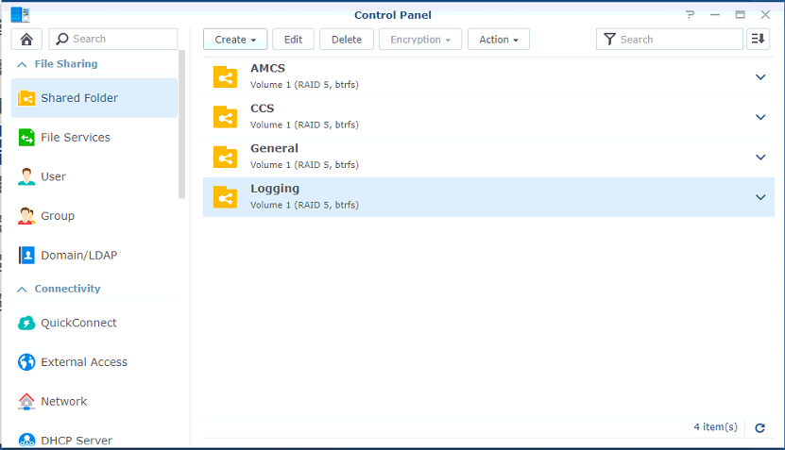

The NAS contains the following users:

* AMCS: can only read and write the AMCS back up (for access from AMCS)
* CCS: can only read and write the CCS back up (for access from CCS)
* Logging: can read all the back-up folders (AMCS | CCS | General) and read and write the loggings folder (all users except the elec).
* adl_local: user used by the elec. >> read and write on AMC, CCS and General
* adl_tse: user used by IT support. >> read and write on all folders
* admin: user only used for emergency >> admin

## Setup snapshots

Open package center

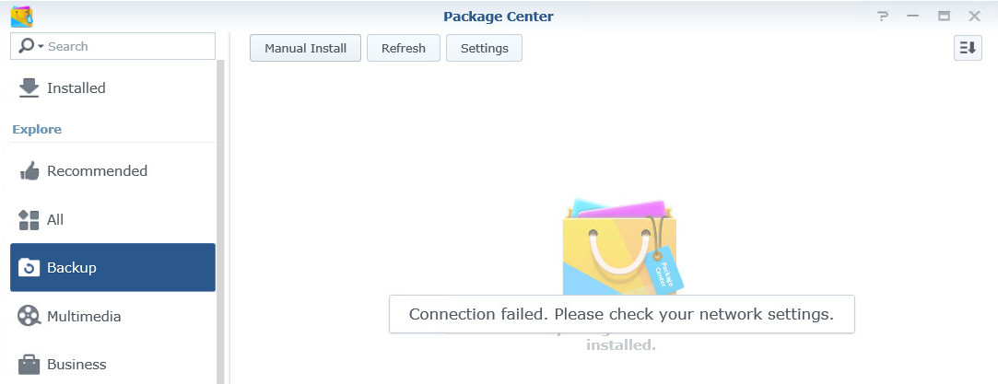

If the synology still has internet access then the package “Snapshot Replication” can be installed by searching for it.

In case there is no internet connection, download the package manually on the website: <https://www.synology.com/en-us/support/download/RS815+#packages>

Then select manual install and select the downloaded SPK file.

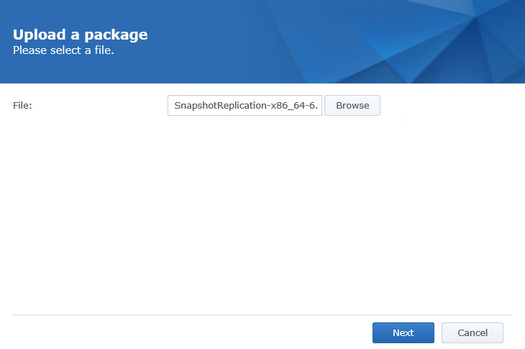

One installed open Snapshot Replication.

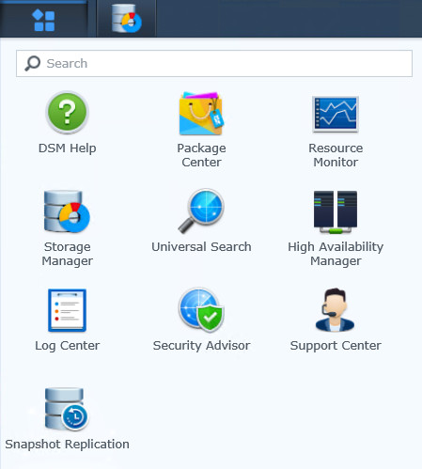

Go to snapshots, all shares should be visible here

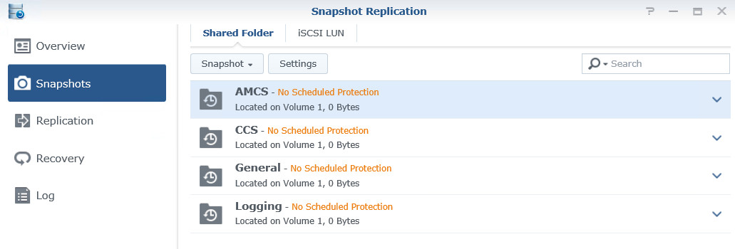

Now open settings per share and apply snapshot settings as shown below.

Run Hourly

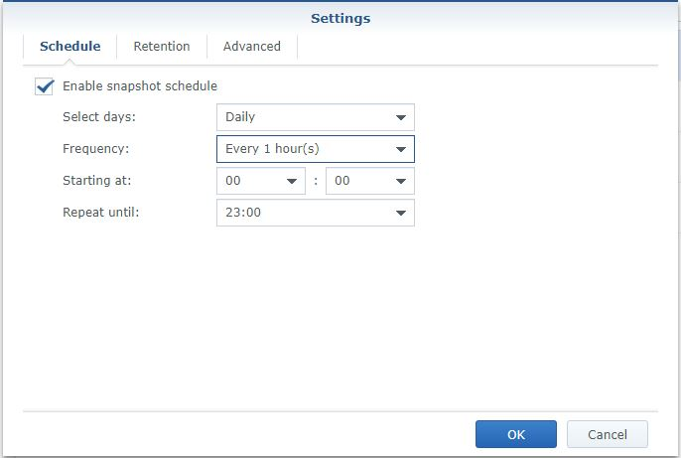

With retention of:

* 12 hourly
* 3 daily
* 3 weekly
* 3 monthly
* 1 yearly

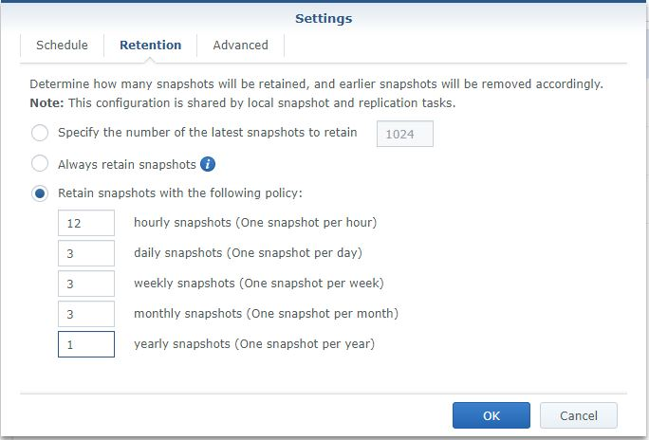

And apply settings.

Do not set snapshots on shares that are used to backup PC’s using Veeam or Symantec etc.

## Login Style

Control Panel > Theme > Login Style

**Login page Title:** <vesselname> Machine NAS

**Welcom Title:** UNAUTHORIZED USE OF THIS SYSTEM IS STRICTLY PROHIBITED!

**Welcome Message:** Please contact the ICT-Servicedesk to gain access.

